**SOLUTION ARCHITECTURE**

**Design:**

* The recipient can track donor details and his health condition to accept his plasma.
* Sending SMS/OTP automatically when the recipient finds a donor
* The location of the donor and the status of the donor can be tracked.

**Software and system required:**

* Python
* Flask
* Docker
* 8GB RAM, Intel Core i3
* OS-Windows/Linux/MAC
* Laptop or Desktop

**Block Diagram:**

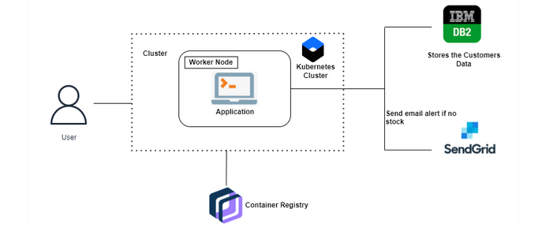

**Cloud Services:**

